Industrial ladders
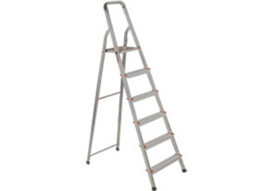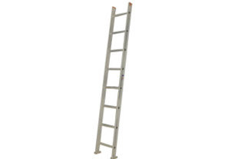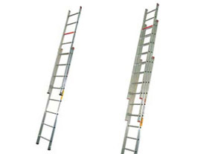

Aluminium Step Ladders Aluminium Wall Supporting Ladders Aluminium Wall Supporting Extension Ladders

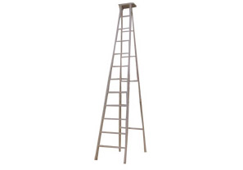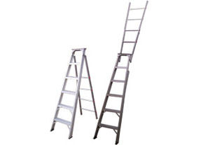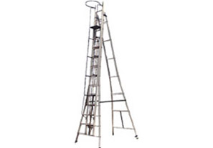

Aluminium Self Supporting Ladders Combination Ladders Aluminium Self Supporting Extension Ladders

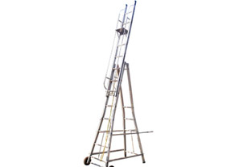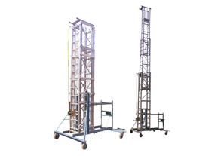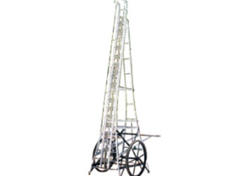

Polymer Wheeled Extention Ladders Tiltable Tower Ladders Road Star Tower Ladder

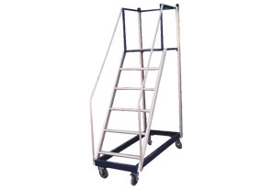

Aluminium Trolley Step Ladders

